IMPORTED DATA USING TRASFORM MAPS
(SPREAD SHEET)
Project Testing Phase
Testing Objectives
The main objective of testing is to verify that the spreadsheet data is imported into ServiceNow correctly using Import Sets and Transform Maps.
Testing helps identify incorrect field mappings, missing data, duplicate records, and transformation errors.
Test Data
The Excel spreadsheet used for the project is used as the test data. The test data contains employee information such as Employee Name, Employee ID, Email, Department, and Phone Number.
The data is checked before importing to ensure that the values are correct and properly formatted.
Test Cases
The following test cases are performed during the project:
Test Case| Expected Result
Upload Excel file| File should be uploaded successfully
Import spreadsheet data| Records should load into the Import Set Table
Create Transform Map| Transform Map should be created successfully
Map source fields| Fields should map correctly to target fields
Run transformation| Records should be transferred to the target table
Verify imported records| Records should match the original Excel data
Import Data Validation
After uploading the spreadsheet, the imported records are checked in the Import Set Table.
The number of records and field values are compared with the original Excel spreadsheet to ensure that the data has been loaded correctly.

Field Mapping Validation
The source fields and target fields are checked to ensure that each field is mapped correctly.
For example:
Employee Name →SB000, SB0002, SB0003, SB0004, SB0005, SB0006
Employee ID → User1, User2, User3, User4, User5, User6
Email → user1@gmail.com, user2@gmail.com, user3@gmail.com, user4@gmail.com, user5@gmail.com, user6@gmail.com,
Department → ServiceNow, ServiceNow, ServiceNow, ServiceNow, Salesforce, Salesforce
Location→ Tamil Nadu, Tamil Nadu, Tamil Nadu, Tamil Nadu, Tamil Nadu, Tamil Nadu,
Correct mapping ensures that the data appears in the appropriate target fields.
Transform Map Testing
The Transform Map is tested by running the transformation process. The transformation results are reviewed to confirm that the source records are successfully transferred to the target table.
Both successful and failed records are checked.
Error Handling
If an error occurs during the import or transformation process, the Import Set and Transform Map results are reviewed to identify the problem.
Common issues such as incorrect field mapping, invalid data format, missing values, or duplicate records are corrected, and the transformation is tested again.
Test Results
The testing process confirms that the Excel spreadsheet data is successfully imported into ServiceNow and transferred to the target table.
The source and target records are compared to verify data accuracy and field mapping. The final test results show that the Import Set and Transform Map process works as expected.

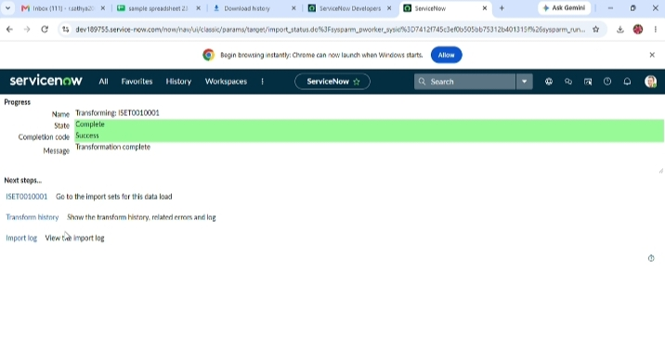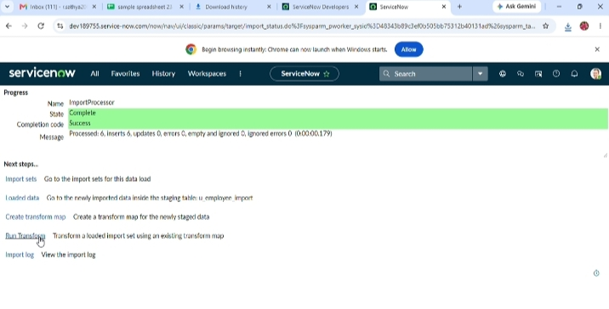

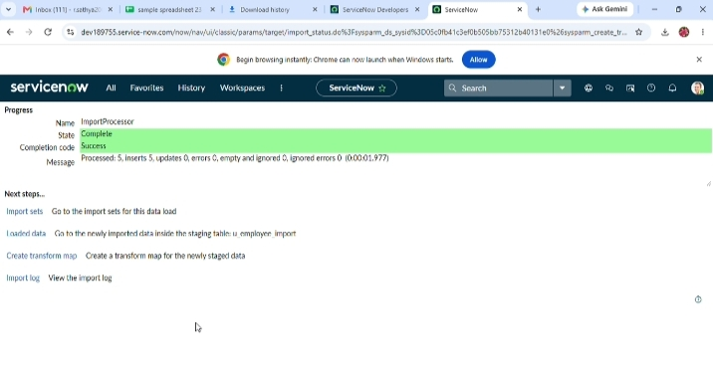
Screenshot 1: Data import completed successfully - 5 records processed and inserted into the staging table u_employee_import.
Screenshot 2: Transformation completed successfully for import set ISET0010001.
Screenshot 3: Data load completed successfully - 6 records processed and inserted into the staging table u_employee_import.

